Aim: Exploring packet sniffing using Wireshark

What is Packet Sniffing?
Packet sniffing (also called packet capturing or network analysis) is the process of intercepting, capturing, and inspecting data packets that travel across a network. Every piece of data transmitted over a network whether a web page request, an email, or a file transfer is broken down into smaller units called packets before being sent. A packet sniffer captures these packets as they pass through a network interface, allowing an analyst to examine their contents, structure, and behavior.

What is Packet sniffing is used for?
- Network troubleshooting: Diagnosing latency, dropped packets, and connectivity issues.
- Security analysis: Detecting intrusions, malware communication, and suspicious traffic.
- Performance monitoring: Measuring bandwidth usage and identifying bottlenecks.
- Protocol learning: Understanding how protocols like TCP, HTTP, and DNS actually work.
- Forensics: Investigating security incidents after they occur.

What is Wireshark?
Wireshark is a free, open-source, cross-platform network protocol analyzer. It is the most widely used packet sniffer in the world, used by network administrators, security professionals, developers, and students. It allows users to:
- Capture live traffic from a network interface in real time.
- Open and analyze previously saved capture files (`.pcap`, `.pcapng`).
- Inspect packets at a deep level, from the frame up through the application layer.
- Apply filters to isolate specific traffic of interest.
- Reconstruct data streams (e.g., follow a TCP stream, extract files).

How does Packet Sniffing Works?
A network interface card (NIC) normally operates in one of two modes:
Mode | Behavior
Promiscuous Mode | The NIC captures all packets on the network segment, not just those addressed to it.
Monitor Mode | Used for wireless interfaces; captures all 802.11 frames without associating to a network.

What are the Common Protocols in Wireshark?
- ARP: Resolves IP addresses to MAC addresses.
- ICMP: Used by `ping` and `traceroute`.
- DNS: Resolves domain names to IP addresses (usually UDP port 53).
- TCP: Connection-oriented transport; observed via the 3-way handshake (SYN, SYN-ACK, ACK).
- UDP: Connectionless transport; used by DNS, DHCP, streaming.
- HTTP/HTTPS: Web traffic; HTTP is plaintext (port 80), HTTPS is encrypted (port 443, TLS).
- DHCP: Assigns IP addresses dynamically.

List Applications of Packet Sniffing.
- Troubleshooting slow networks: Identify retransmissions, duplicate ACKs, or high latency.
- Detecting malicious activity: Look for unusual ports, beaconing, or plaintext credentials.
- Analyzing protocol behavior: Observe handshakes, flags, and payloads.
- Verifying network policies: Ensure only permitted traffic is on the wire.
- Educational purposes: Learn how networking protocols actually function.

What are the Ethical and Legal Considerations?
- Authorization is mandatory: Only capture traffic on networks you own or have explicit written permission to monitor.
- Privacy laws: Capturing others' data may violate laws such as GDPR, HIPAA, or the IT Act (India).
- Encryption limits visibility: HTTPS, TLS, and VPN traffic is encrypted; sniffers see metadata but not content.
- Professional ethics: Security analysts must handle captured data responsibly and never misuse it.

List Advantages and Limitations of Wireshark
Advantages:
- Free, open-source, and cross-platform.
- Deep protocol dissection (thousands of protocols).
- Powerful filtering and statistical tools.
- Supports live capture and offline analysis.
- Large community and extensive documentation.
Limitations:
- Cannot decrypt encrypted traffic without keys.
- On switched networks, requires port mirroring or special configuration.
- Consumes significant memory/CPU on high-traffic links.
- GUI can be overwhelming for beginners.
- Does not actively detect intrusions it is an analysis tool, not an IDS.

Installing Wireshark

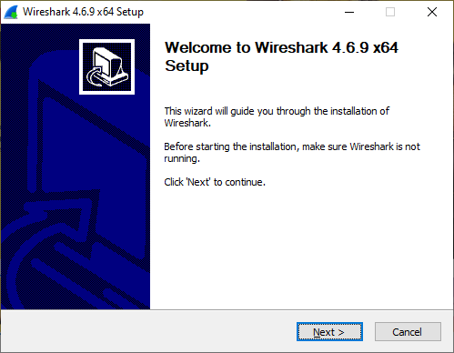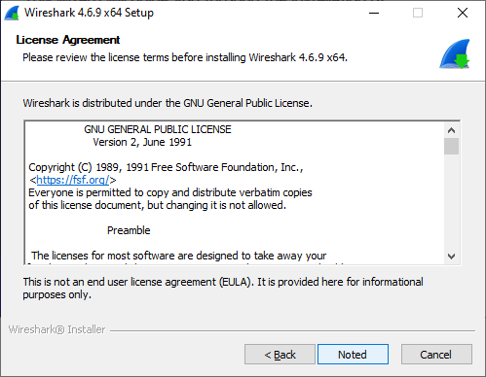

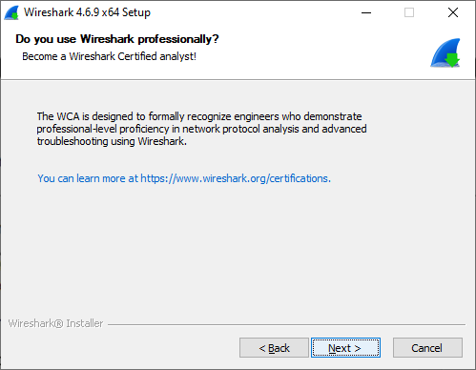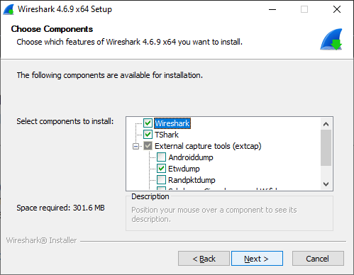

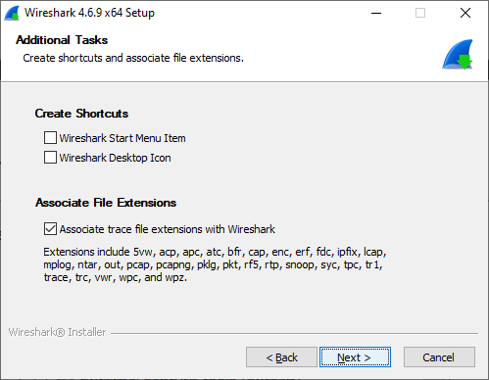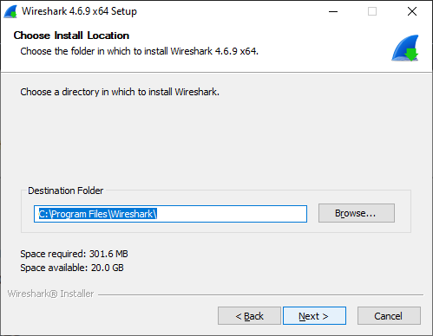

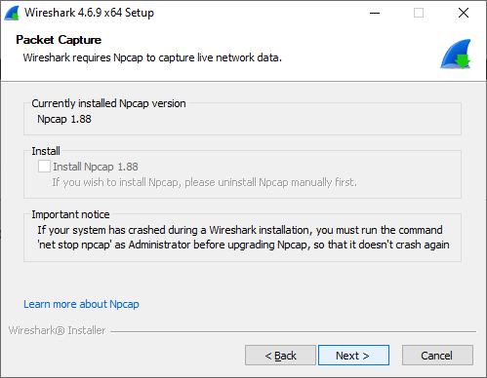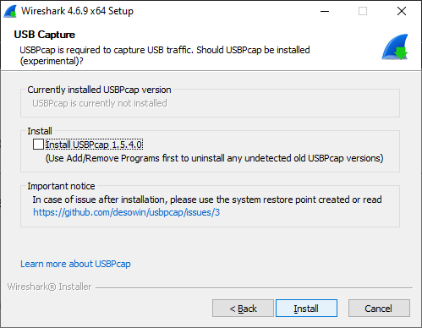

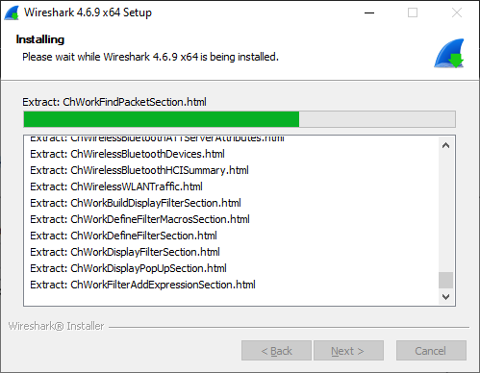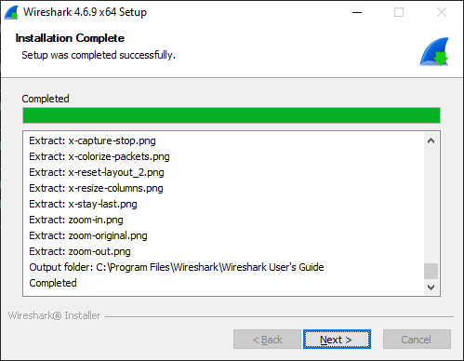

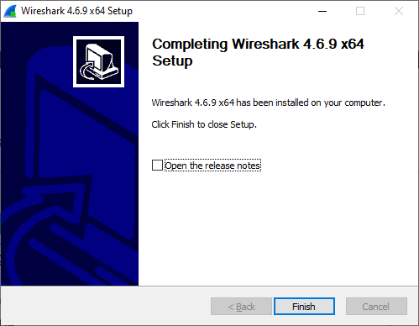

Sniffing Playstation Packet


Opened Playstation Website

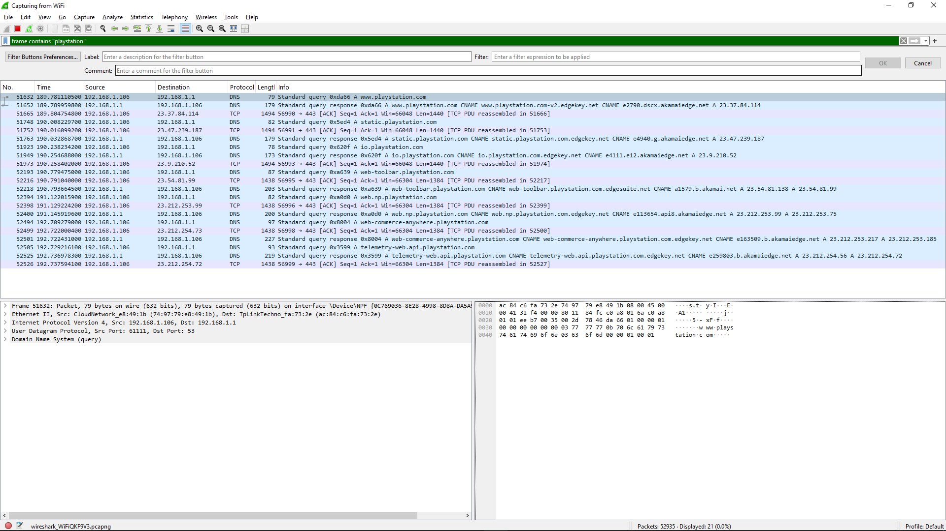
Found “Playstation“ Packet in Wireshark
Sniffing Steam Packet

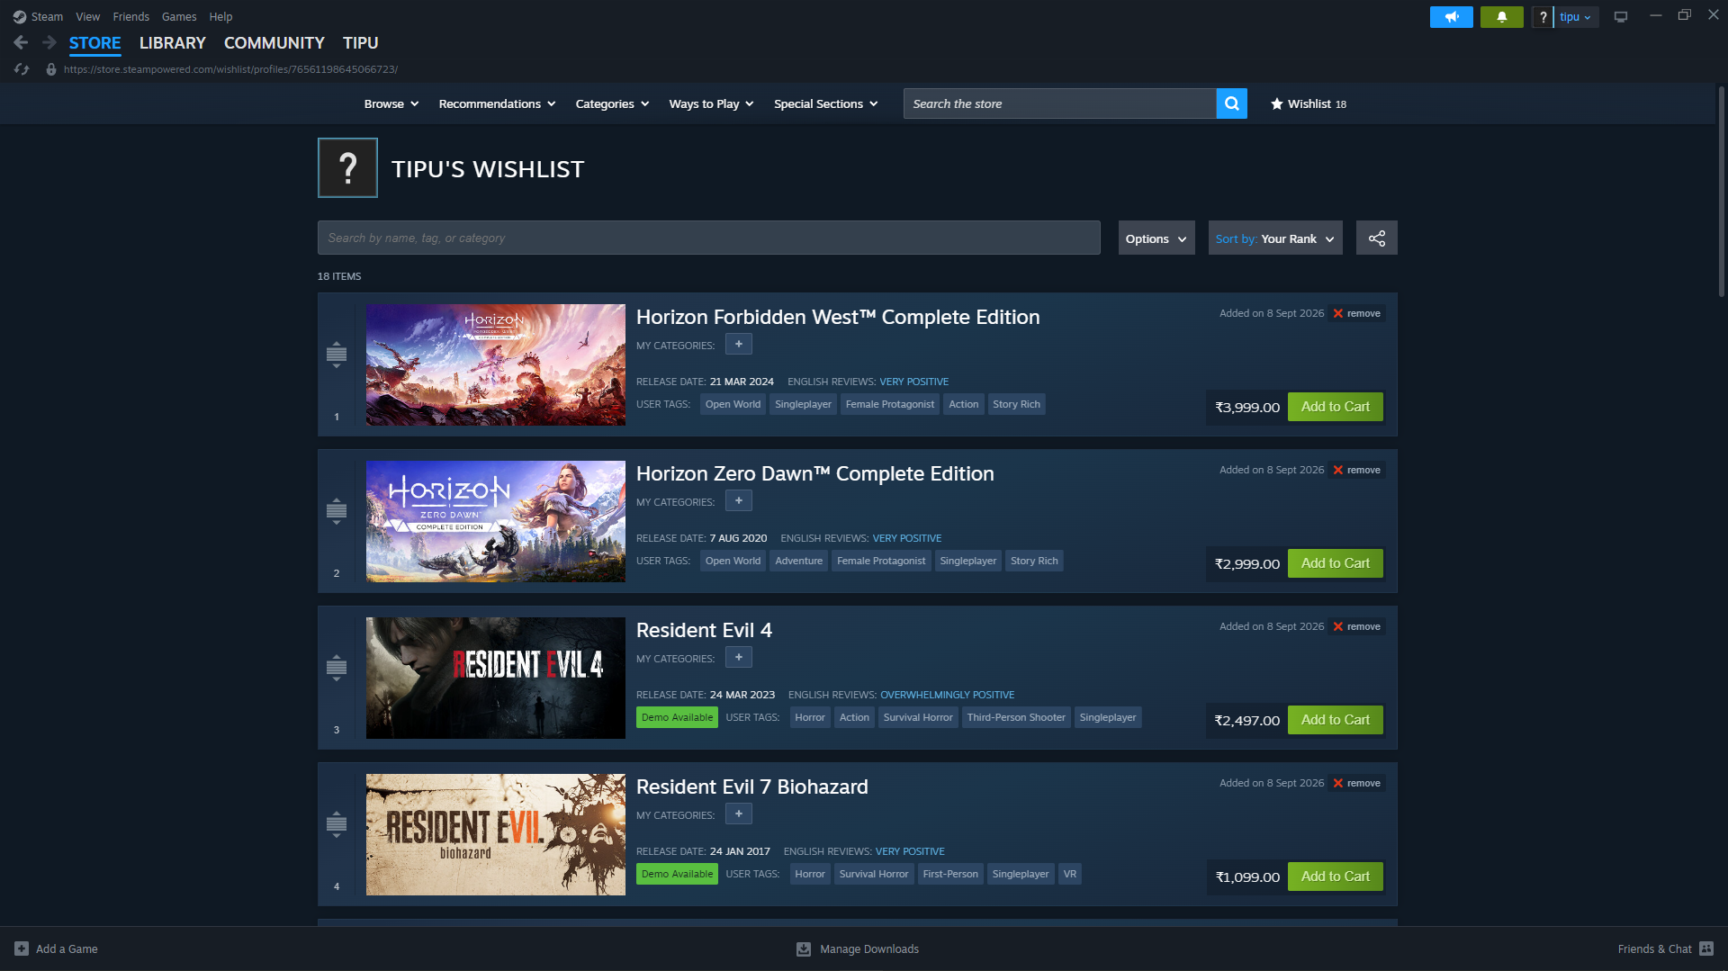
Opened Steam Application

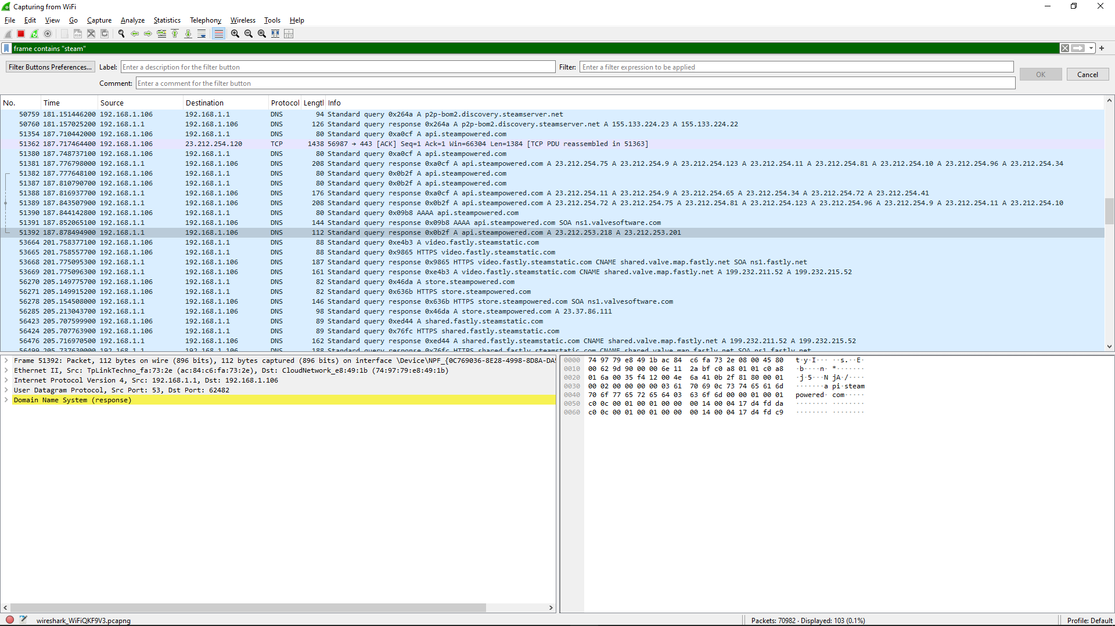
Found “Steam“ Packet in Wireshark
Sniffing Steam Packet

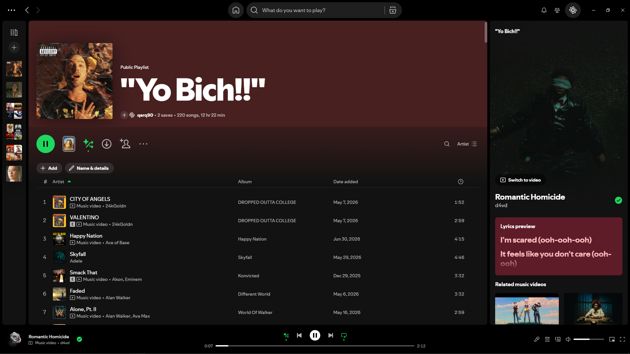
Opened Spotify Application

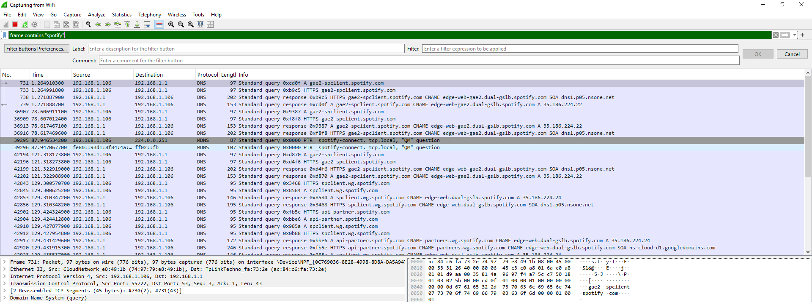
Found “Spotify“ Packet in Wireshark

Conclusion
Wireshark is an indispensable tool for anyone studying computer networks or cybersecurity. It transforms raw network traffic into readable, structured information, enabling learners and professionals to observe how data actually flows across a network. By understanding packet sniffing theory how capture works, the difference between capture and display filters, protocol layering, and the ethical boundaries a student can safely and effectively explore network behavior in a hands-on lab environment.

